LOCATION : GENERAL
DATE : 09.06.2017
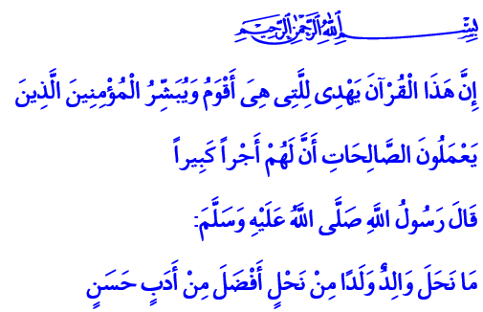
LET’S LEARN QURAN IN THE MONTH OF QURAN
A Blessed Friday to You, Brothers and Sisters!
Our Beloved Prophet (pbuh) came to al-Mashid an-Nabawi with his grandson to lead the isha prayer for his companions. He unusually extended one of the prostrations during prayer, so much so that the companions thought something had happened to Allah’s Messenger or a revelation had arrived. When the prayer was finally over, the distinguished companions asked him why he extended the prostration. The Messenger of Mercy answered: “It is not what you think. My grandson climbed my back during prostration. I waited for him to climb down so he would be happy and not fall and hurt himself.”
Honorable Believers!
In the words of the Holy Book, our children are the light of our eyes. They are the joy of our heart. They are the adornment for earthly life. They are one of the most important things Allah entrusted to us. That’s why we as believers call our dear kids to Islam with the first azan we recite into their ear. Every child who accepts this call by nature learns from us how to love, believe, and trust. It is our duty to nurture their soul without hurting their creation. It is our duty to introduce them to Allah and the Prophet, give them the habit of worshipping, and instill good morals in them.
Dear People in the Mosque!
It must be the primary goal in life for all of us to read, accurately understand, and duly experience the Holy Quran. Because Quran will guide us to salvation. This Great Book brings bliss in both worlds to people who believe in it and abide by it. “Indeed, this Qur'an guides to that which is most suitable and gives good tidings to the believers who do righteous deeds that they will have a great reward.”
Dear Muslims!
We must introduce our children to the basic values of Quran at an early age so they may grow up under Quran’s guidance. Because their souls are closer than everyone to Quran’s spiritual table. Their young minds, innocent hearts are more open to our Book’s message than everyone. If we want to enlighten and make their life fruitful with Quran, Ramadan is the perfect time.
Brothers and Sisters!
A great opportunity is coming up for our children to learn about our Great Book, the exemplary life of our Prophet, and meet the mosque, the minbar, and the mihrap. Our summer Quran courses begin on June 12. Our mosques and courses will be populated once again by our children, the light of our eyes, with the call “Let’s Learn Quran in the Month of Quran.” Let us remember that teaching our Great Book to our children is both a duty as parents and also the greatest inheritance we can pass on to them. Our Prophet (pbuh) stated this fact as such: “No parent has passed down on to their kid something more valuable than good morals.”
Dear Brothers and Sisters!
Come! Let us introduce our children, a great blessing from Allah to us, to the graceful messages of the Quran. Come! Let us equip our kids with wisdom, knowledge, and manners. Let us not leave them without Quran. Let us make their hearts, minds, and future thrive with Quran. Let us use Ramadan as an opportunity to raise sincere Muslims who lead their life with Quran in their hands and faith in their hearts. Let us work to raise generations that know Allah’s Book, pattern themselves after Allah’s Messenger, and are committed to their religion and nation with loyalty. Let us reveal the Quran, which was revealed in this blessed month, first to our hearts then to the hearts of our children.
I would like to finish my khutbah with the following prayers Allah taught us in the Holy Quran:
“Our Lord! Grant unto us wives and offspring who will be the comfort of our eyes, and give us the grace to lead the righteous.”
“My Lord, make me an establisher of prayer, and many from my descendants. Our Lord, and accept my supplication.”

An-Nasai, Tatbik, 82.
Al-Isra, 17/9.
Tirmidhi, Birr, 33.
Al-Furqan, 25/74.
Ibrahim, 14/40. Written by: General Directorate of Religious Services

